## DAY 4

**#1**

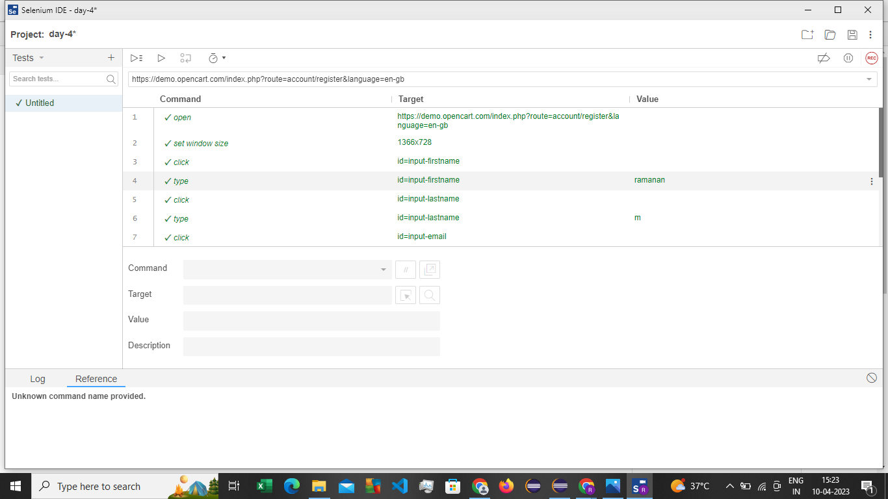

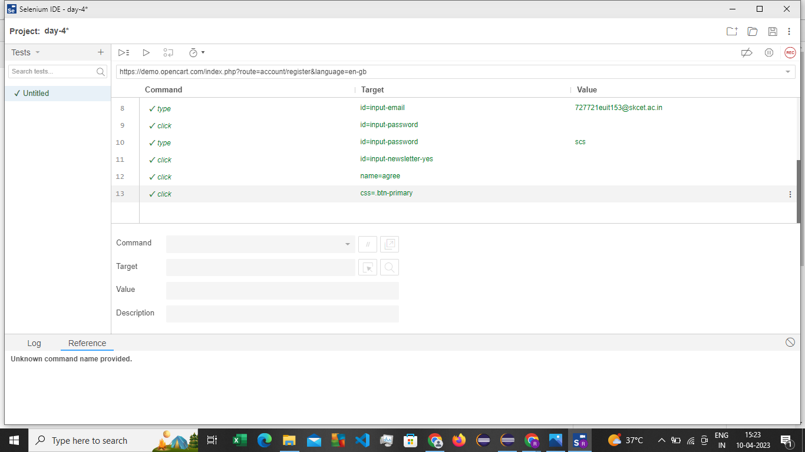

**#2**

**package** com.test.selenium;

**import** org.openqa.selenium.By;

**import** org.openqa.selenium.WebDriver;

**import** org.openqa.selenium.WebElement;

**import** org.openqa.selenium.chrome.ChromeDriver;

**import** org.openqa.selenium.chrome.ChromeOptions;

**import** io.github.bonigarcia.wdm.WebDriverManager;

/**

* Hello world!

*

*/

**public** **class** Day4two

{

**public** **static** **void** main( String[] args ) **throws** InterruptedException

{

ChromeOptions co=**new** ChromeOptions();

co.addArguments("--remote-allow-origins=*");

WebDriverManager.*chromedriver*().setup();

WebDriver driver =**new** ChromeDriver(co);

driver.get("https://demo.opencart.com/index.php?route=account/register&language=en-gb");

Thread.*sleep*(5000);

WebElement el= driver.findElement(By.*name*("firstname"));

el.sendKeys("Ramanan.m");

WebElement el2= driver.findElement(By.*name*("lastname"));

el2.sendKeys("V");

WebElement el3= driver.findElement(By.*name*("email"));

el3.sendKeys("727721euit125@skcet.ac.in");

WebElement el4= driver.findElement(By.*name*("password"));

el4.sendKeys("ramanan.m");

WebElement el5= driver.findElement(By.*name*("agree"));

el5.click();

WebElement el6= driver.findElement(By.*xpath*("//*[@id=\"form-register\"]/div/div/button"));

el6.click();

// bt.click();

}

}

**#3**

**package** com.test.selenium;

**import** org.openqa.selenium.By;

**import** org.openqa.selenium.JavascriptExecutor;

**import** org.openqa.selenium.WebDriver;

**import** org.openqa.selenium.chrome.ChromeDriver;

//import org.openqa.selenium.chrome.ChromeDriver;

**import** org.openqa.selenium.chrome.ChromeOptions;

**import** io.github.bonigarcia.wdm.WebDriverManager;

**public** **class** dayfour_3 {

**public** **static** **void** main(String[] args) **throws** InterruptedException {

ChromeOptions co=**new** ChromeOptions();

co.addArguments("--remote-allow-origins=*");

WebDriverManager.*chromedriver*().setup();

WebDriver driver=**new** ChromeDriver();

driver.get("https://demo.opencart.com/index.php?route=checkout/voucher&language=en-gb");

driver.findElement(By.*xpath*("//input[@id=\"input-to-name\"]")).sendKeys("Sreehari");

driver.manage().window().maximize();

JavascriptExecutor js=(JavascriptExecutor) driver;

js.executeScript("window.scrollBy(0,500)","");

Thread.*sleep*(5000);

driver.findElement(By.*xpath*("//input[@id=\"input-theme-6\"]")).click();

driver.findElement(By.*xpath*("//*[@id=\"form-voucher\"]/div[8]/div/div/input")).click();

driver.findElement(By.*xpath*("//*[@id=\"form-voucher\"]/div[8]/div/button")).click();

}

}

**#4**

**package** com.test.selenium;

**import** org.openqa.selenium.By;

**import** org.openqa.selenium.WebDriver;

**import** org.openqa.selenium.WebElement;

**import** org.openqa.selenium.chrome.ChromeDriver;

**import** org.openqa.selenium.chrome.ChromeOptions;

**import** io.github.bonigarcia.wdm.WebDriverManager;

**public** **class** day4_four {

**public** **static** **void** main( String[] args ) **throws** InterruptedException

{

ChromeOptions co=**new** ChromeOptions();

co.addArguments("--remote-allow-origins=*");

WebDriverManager.*chromedriver*().setup();

WebDriver driver =**new** ChromeDriver(co);

driver.get("https://j2store.net/free/");

Thread.*sleep*(5000);

WebElement el6= driver.findElement(By.*xpath*("//*[@id=\"Mod112\"]/div/div/ul/li[1]/a"));

el6.click();

driver. navigate(). back();

driver. navigate(). forward();

driver. navigate(). refresh();

}

}

Output

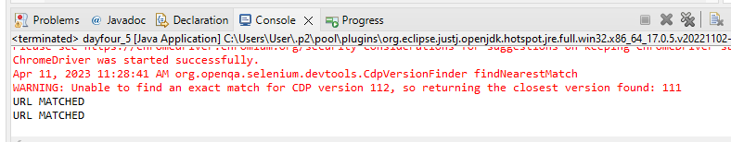

**#5**

**Task-5.1**

package com.test.selenium;

import org.openqa.selenium.By;

import org.openqa.selenium.WebDriver;

import org.openqa.selenium.WebElement;

import org.openqa.selenium.chrome.ChromeDriver;

import org.openqa.selenium.chrome.ChromeOptions;

import io.github.bonigarcia.wdm.WebDriverManager;

public class dayfour_5 {

public static void main(String []Args) {

ChromeOptions co=new ChromeOptions();

co.addArguments("--remote-allow-origins=*");

WebDriverManager.chromedriver().setup();

WebDriver driver =new ChromeDriver(co);

driver.get("https://j2store.net/free/");

String cUrl=driver.getCurrentUrl();

if(cUrl.equals("https://j2store.net/free/")) {

System.out.println("URL MATCHED");

}

else {

System.out.println("URL NOT MATCHED");

}

WebElement el6= driver.findElement(By.linkText("Clothing (5)"));

el6.click();

String cUrl1=driver.getCurrentUrl();

if(cUrl1.equals("https://j2store.net/free/index.php/shop?filter_catid=11")) {

System.out.println("URL MATCHED");

}

else {

System.out.println("URL NOT MATCHED");

}

}

}

**Task ex-2**

package com.test.selenium;

import org.openqa.selenium.By;

import org.openqa.selenium.WebDriver;

import org.openqa.selenium.WebElement;

import org.openqa.selenium.chrome.ChromeDriver;

import org.openqa.selenium.chrome.ChromeOptions;

import java.util.*;

import io.github.bonigarcia.wdm.WebDriverManager;

public class findingName {

public static void main(String []Args) {

ChromeOptions co=new ChromeOptions();

co.addArguments("--remote-allow-origins=*");

WebDriverManager.chromedriver().setup();

WebDriver driver =new ChromeDriver(co);

driver.get("https://j2store.net/free/");

WebElement el6= driver.findElement(By.linkText("Clothing (5)"));

el6.click();

List<WebElement> li=driver.findElements(By.xpath("//h2[@itemprop=\"name\"]"));

for(WebElement e:li) {

System.out.println(e.getText());

}

}

}

**Output**

